Source https://www.getyourguide.com/tenerife-l350/loro-parque-siam-park-1-ticket-2-attractions-t407438/?ranking_uuid=ce6967dd-65d1-4a05-9af0-abd86e5744ad
__________________________________________________________

Ultimate Tenerife Twin Park Experience: Loro Parque & Siam Park Access
__________________________________________________________
★★★★★ 4.5/5 20 reviews

Add to wishlist ♡

__________________________________________________________

Flexible 14-Day Access | €90 per person

🏕  Image | 🏕  Image | 🏕  Image | 🏕  Image | 🏕  Image | 🏕  Image

__________________________________________________________
Experience Introduction
Unlock two of Tenerife’s most celebrated attractions with a single dual-entry pass granting admission to both Loro Parque and Siam Park. This combination experience blends wildlife discovery with aquatic adventure, allowing you to witness remarkable animal presentations, explore immersive habitats, and enjoy thrilling water attractions. With 14 days of flexibility after first use, you can schedule each visit at your own pace and fully enjoy both parks without rushing.
__________________________________________________________
Essential Tour Details
- Duration: Valid for 14 days after first activation
- Meeting point: Loro Parque is located in Puerto de la Cruz (north Tenerife) and can be reached via the Loro Parque Express train departing every 20 minutes from Plaza de Los Reyes Católicos. Siam Park is situated at Av. Siam, Costa Adeje, with complimentary shuttle buses available from select locations.
- Group Size: Per-person ticket access
- Accommodation: Not included (entry-only experience)
- Languages Available: English
- Private Guide: Not included
- Transportation: Not included (complimentary local shuttles may operate separately)
- Season: Available year-round
__________________________________________________________

Check Dates & Availability

Select participants: (Age 99 and younger) - 1 +

Choose date:
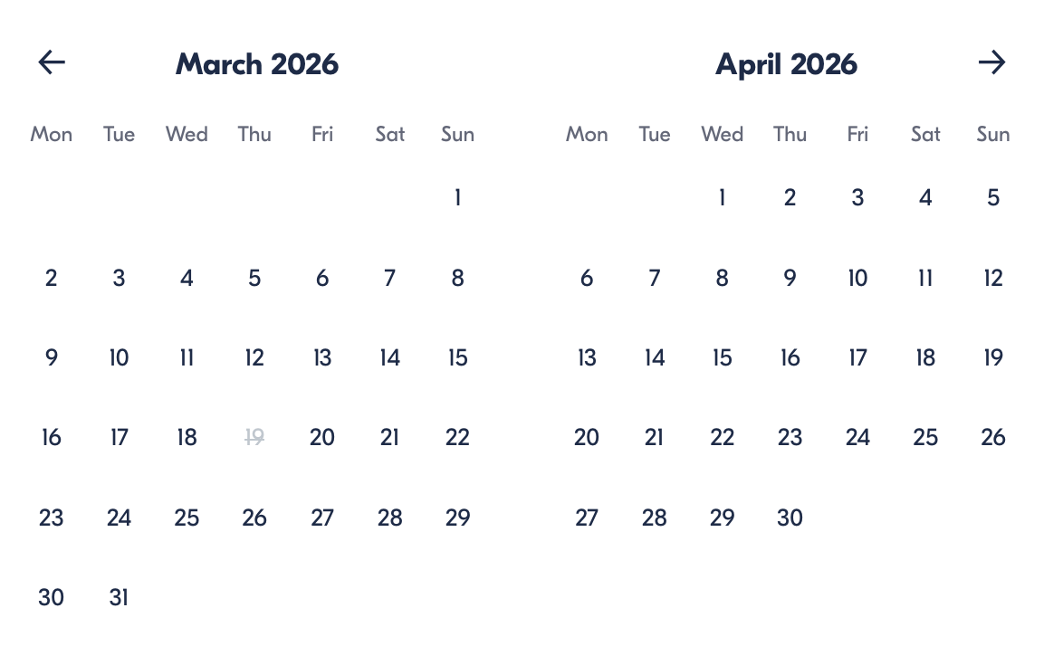

Check Availability

opens:

Participants: 1 February 19, 2026

Ultimate Tenerife Twin Park Experience: Loro Parque & Siam Park Access

- Duration: 14 days validity
- Offered in: Not specified (self-guided ticket)
- Starts at: 9:30 AM

Cancellation:

- Cancel more than 24 hours before start — full refund
- Cancel within 24 hours or no-show — no refund
Price breakdown: 1 Participant × €90 per person
Total: €90 per person

The total price includes all taxes and fees.

Add to cart Book now

__________________________________________________________
Tour Features
- Loro Parque Wildlife Experience: Explore one of the world’s most acclaimed zoological parks, known for its conservation efforts and immersive habitats.
- Live Animal Performances: Enjoy impressive presentations featuring parrots, marine species, and other fascinating animals.
- Family Adventure Zones: Children can climb, explore, and play in the elevated Kinderlandia playground.
- Siam Park Water Kingdom: Discover Europe’s most celebrated water park filled with thrilling rides and relaxing attractions.
- Exotic Design Atmosphere: Experience beautifully crafted Thai-inspired architecture surrounded by lush tropical scenery.
__________________________________________________________
Detailed Itinerary
- Day 1 – Suggested Visit: Loro Parque
Begin your experience in northern Tenerife at Loro Parque, one of the Canary Islands’ most renowned attractions. Wander through lush botanical surroundings, encounter animals from across the globe, and enjoy four outstanding live presentations. One of the standout highlights is the famous Orca Ocean show. Younger visitors can climb, explore, and play in the elevated Kinderlandia activity zone while adults take in the park’s beautifully landscaped environment.
Accommodation:
Not included (admission-only experience)
__________________________________________________________
- Day 2 – Suggested Visit: Siam Park
Continue your adventure with a visit to Siam Park, widely regarded as Europe’s premier water park. Discover a wide range of attractions, from high-energy slides to relaxing pools suitable for all ages. The park’s scenery blends tropical landscapes with elaborate Thai-inspired architecture, creating an immersive atmosphere that feels both exotic and exciting.
Accommodation:
Not included (admission-only experience)
__________________________________________________________
Included in Price
- Admission ticket to Loro Parque
- Admission ticket to Siam Park
- Skip-the-line entry convenience
- All taxes and booking charges included in the final price
__________________________________________________________
Not Included
- Meals and beverages
- Transportation between parks
- Guided services or hosted tours
__________________________________________________________
Who Should Avoid This Tour
- Travelers expecting guided excursions or structured group tours, as this is an independent ticket experience
- Visitors seeking bundled packages with hotels or transfers included
- Guests sensitive to busy environments, especially during peak visitor periods
__________________________________________________________
Important Trip Info
- Validity Window: Your combined ticket remains valid for 14 days after first activation, allowing flexibility to visit each park on different days.
- Operating Hours: Both attractions operate from 9:30 AM to 5:30 PM.
- Entry Verification: Fingerprint confirmation is required upon first entry for ticket validation. A valid ticket must still be presented at each park entrance.
- Park Locations: Loro Parque and Siam Park are situated in different areas of Tenerife, so travel between them must be arranged independently.
- Children Policy: Children under 6 years old receive free admission and do not require a ticket.
- Local Resident Rates: Special pricing for Canary Islands residents may be available directly at the parks’ ticket offices.
- Temporary Closure Notice: The dolphin stadium at Loro Parque is closed from April 15 through May 21, 2024, and dolphin shows will not be available during that period.
- Visit Planning Tip: Because the ticket remains valid for two weeks after first use, you can schedule each visit according to your preferred travel pace.
- Arrival Recommendation: Arriving earlier in the day helps maximize time inside each park and enjoy more attractions.
- Assistance: On-site staff at both parks are available to assist visitors during opening hours if needed.
__________________________________________________________

Cancellation Policy
For Individual Bookings:
- Cancellations made more than 24 hours before the scheduled start time qualify for a full refund of the booking amount.
- Requests submitted within 24 hours of the activity start time or failure to attend are non-refundable.
Price adjustments may occur if participant numbers are modified. Travel insurance is strongly recommended to protect your reservation.
Refund Processing:
Eligible refunds are issued after cancellation approval according to the policy timeframe.
__________________________________________________________
What Our Clients Are Saying

Overall rating  4.5/5  ★★★★★  Based on 20 reviews | Review summary  Guide 4.5/5  Transportation 4.6/5  Service 4.7/5  Organisation 4.5/5

Filter  - All traveller types  - Couples  - Group of friends  - Families  By star rating  - All star ratings  - 5 stars  - 4 stars  - 3 stars  - 2 stars  - 1 star | Search reviews (e.g., guide)  Sort by:  - Top picks  - Latest reviews  - Best ratings  - Lowest ratings
__________________________________________________________
★★★★★
Marco L. – Italy
We had an amazing day visiting both parks. The animals at Loro Parque were fascinating, and Siam Park was packed with fun rides. Perfect combination for families.

★★★★★
Sophie K. – France
Such a great experience in Tenerife. Loro Parque was beautiful and educational, while Siam Park was exciting and refreshing. Booking the combo ticket was definitely worth it.

★★★★☆
Daniel R. – United Kingdom
Both parks were fantastic and very well organized. Loro Parque impressed us with its variety of animals, and Siam Park was full of thrilling attractions. It can get busy, but overall, it was excellent.

See more reviews
__________________________________________________________

Meta tags

Page - Ultimate Tenerife Twin Park Experience: Loro Parque & Siam Park Access

Title: Loro Parque & Siam Park Combo Ticket | Travellio Global

Description: Visit two of Tenerife’s top attractions with one flexible ticket. Enjoy wildlife shows at Loro Parque and thrilling rides at Siam Park with 14-day access between visits.

H1 - Ultimate Tenerife Twin Park Experience: Loro Parque & Siam Park Access
__________________________________________________________

